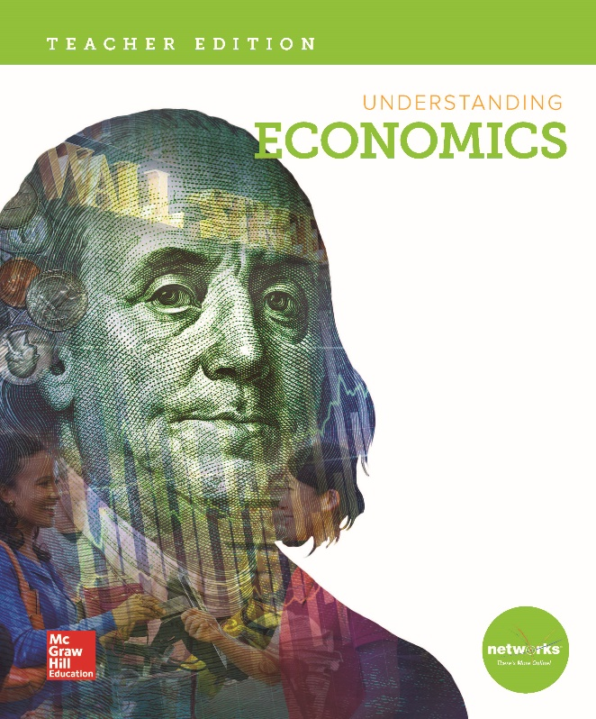

©2018

High School Economics

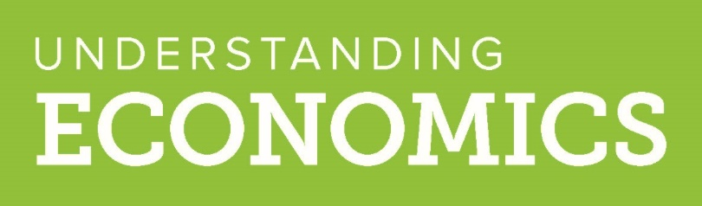

STANDARDS |  |  | PAGE REFERENCES
 |  | E1 The Market Economy
1.1 Individual, Business, and Government Decision Making
Individually and collaboratively, students will engage in planned inquiries to explain and demonstrate how individuals confront scarcity, and how market forces influence how they organize, produce, use, and allocate resources in its presence.
1.1.1 Scarcity, Choice, Opportunity Costs, Incentives – using examples, explain how scarcity, choice, opportunity costs, and incentives affect decisions made by households, businesses, and governments. |  |  | Student Edition:  9-11, 14-16, 21-29, 30-31, 45-46, 58, 72-78, 102-105, 107, 400-401, 498, 546-549  Case Study 107  Illustration 12  Teacher Edition:  NOTO 10; R 10, 74, 546, 548; R1 401; R2 401; W 400; W1 45
1.1.2 Entrepreneurship – analyze the risks and rewards of entrepreneurship and associate the functions of entrepreneurs with alleviating problems associated with scarcity. |  |  | Student Edition:  14-18, 73-74, 82-83  Teacher Edition: 82, 83; C 72, C2 82; NOTO 74, 82, 83;  R 74; R1 83
1.1.3 Marginal Analysis – weigh marginal benefits and marginal costs in decision making. |  |  | Student Edition:  184-186  Networks 183  The Global Economy & You 163  Teacher Edition:  NOTO 163; R 185
1.2 Competitive Markets
Individually and collaboratively, students will engage in planned inquiries to analyze how the functions and constraints of business structures, the role of price in the market, and relationships of investment to productivity and growth, impact competitive markets.
1.2.1 Institutions – describe the roles of various economic institutions and purposes they serve in a market economy.  Examples may include but are not limited to: banks, labor unions, markets, corporations, co-operatives, sole proprietorships, partnerships, and not-for-profit organizations. |  |  | Student Edition:  45-46, 57-58, 72-79, 472-473, 559-560, 564-566, 568, 570-573  Case Study 81  Debates 326-327  Essential Question 558  Teacher Edition:  C1 76; C3 559; EQA 558; NOTO 564, 565, 570; R1 568, 570; R2 568, 570; R4 570; W 44

STANDARDS |  | PAGE REFERENCES
1.2.2 Market Structures – identify the characteristics of perfect competition, monopolistic competition, oligopoly, and monopoly market structures.  Examples may include but are not limited to: number of producers, similarity of products, barriers to entry, control over prices. |  | Student Edition:  182-189, 203  Economic Perspectives 180-181  Essential Questions 179  The Global Economy & You 187  Teacher Edition:  C 181; CMS 179; NOTO 180, 184, 186; V 180; W 180
1.3 Prices, Supply, and Demand
Compare how supply, demand, price, equilibrium, elasticity, and incentives affect the
workings of a market.
1.3.1 Supply And Demand – use the laws of supply and demand to explain household and business behavior.  Examples may include but are not limited to: determinants of demand and determinants of supply. |  | Student Edition:  102-106, 108-119, 128-135  Economic Perspectives 100-101, 126-127  Essential Questions 99, 114, 133  Networks 103, 104, 109, 110, 129, 130, 132, 183  Teacher Edition:  A 114, 130, 133, 134; C 112, 130, 132; C1 131, 133; C2 131, 133; E 99; R 132; MC 99; NOTO 98, 100, 102, 103, 104, 109, 110, 129, 112, 130, 131, 132, 133; R 132; W 112, 113
1.3.2 Price, Equilibrium, Elasticity, and Incentives – analyze how prices change through the interaction of buyers and sellers in a market, including the role of supply, demand, equilibrium, and elasticity, and explain how incentives (monetary and non-monetary) affect choices of households and economic organizations. |  | Student Edition:  9-11, 14-16, 18-20,45-46, 103-105, 160-166, 546-549  Case Study 107  Critical Thinking 12  Essential Question 14  Illustration 12  Networks 18, 103, 104, 109, 110, 129, 130, 132, 161, 162, 165, 183  Study Guide 122  Teacher Edition:  A 14, 163, 164; C 14, 104; MC 18; NOTO 10, 11, 14, 18, 161, 162, 165, 547; R 10, 546, 548

STANDARDS |  | PAGE REFERENCES
1.4 Role of Government in the Market
Individually and collaboratively, students will engage in planned inquiries to describe the varied ways in which government impacts households and businesses through policy decisions, regulatory laws, and ordinances, as well as apply key economic elements to how governments and markets allocate resources differently and explain why these differences matter in terms of growth and prosperity across the mass population.
1.4.1 Public Policy and the Market – analyze the impact of a change in public policy on consumers, producers, workers, savers, and investors.  Examples may include but are not limited to: an increase in the minimum wage, a new tax policy, a change in interest rates, or price controls on the quantity of a good or service. |  | Student Edition:  482-483  Case Study 469  Debates 456-457  Economic Perspective 436-437  Essential Question 478  Teacher Edition:  A 478; C 457, 478; MC 456; NOTO 436, 446, 456, 457, 478; R 468; R1 456; R2 456; W 457
1.4.2 Government and Consumers – analyze the role of government in protecting consumers and enforcing contracts (including property rights) and explain how this role influences the incentives (or disincentives) for people to produce and exchange goods and services. |  | Student Edition:  201, 236-237  Teacher Edition:  C1 236; R 237
1.4.3 Government Revenue and Services – analyze the ways in which local and state governments generate revenue and use that revenue to supply public services. |  | Student Edition:  400-401, 409-410, 413, 418, 420-422, 456-457  Lesson Review 410 #3, #7  Networks 418  The Global Economy & You 454  Teacher Edition:  A 419, 420; NOTO 412, 418, 456, 457; R 410; R1 418, 456; R2 418; V 418; W 420, 457
1.4.4 Market Failure – explain the role for government in addressing both negative and positive externalities.  Examples may include but are not limited to: pollution, vaccinations, education, medical research, government/private partnerships. |  | Student Edition:  158, 161-165  Lesson Review 166 #4  Networks 162, 165  Teacher Edition:  A 166; C 167; IF 167; NOTO 164, 165; W 165
1.4.5 Consequences of Governmental Policy – assess the incentives for political leaders to implement policies that disperse costs widely over large groups of people and benefit small and politically powerful groups.  Examples may include but are not limited to: subsidies, tariffs, import quotas. |  | Student Edition:  436-437, 438-443, 445-449  Aggregate Output-Expenditure Model 439  Networks 446, 448  Teacher Edition:  C 437, 440; C1 441; NOTO 436, 445, 446; R 445, 446; R1 436, 440; R2 436; V 442; W 437, 448

STANDARDS |  | PAGE REFERENCES
1.4.6 Price Controls – analyze the impact of price ceilings and price floors on the quantity of a good or service supplied and demanded in a market. |  | Student Edition:  85, 88-89, 156-157, 170-171, 263-265  Illustration 89  Networks 171, 265  What Happens When 157  Teacher Edition:  C 157; C1 85; C2 85; NOTO 89, 157, 264
 | E2 The National Economy of the United States of America
2.1 Understanding National Markets
Individually and collaboratively, students will engage in planned inquiries to explain why inflation, unemployment, output, and growth in potential output matter to consumers and producers, as well as associate stable money and interest rates with economic prosperity.
2.1.1 Circular Flow and the National Economy – using the concept of circular flow, analyze the roles of and relationship between households, business firms, and government in the economy of the United States. |  | Student Edition:  Circular Flow of Economic Activity 24-26  Exploring the Essential Question 25  Guiding Question 24  Networks 25, 342  The Circular Flow of Finance 305-306  Teacher Edition:  C 24, 25; NOTO 24, 25, 26, 305, 342; V1 25; V2 25; V3 25, 342
2.1.2 Economic Indicators – using a number of indicators, such as gross domestic product (GDP), per capita GDP, unemployment rates, and consumer price index, analyze the current and future state of an economy. |  | Student Edition:  336-340, 382-387  Teacher Edition:  A 382, 384, 385, 387; C 382, 384, 386; C1 387 387; C2 387; NOTO 336, 337, 339, 340, 382, 383, 384; R 340, 386; R2 383; V 382; W 340

STANDARDS |  | PAGE REFERENCES
2.2 Role of Government in the U.S. Economy
Individually and collaboratively, students will engage in planned inquiries to analyze the role of government in the economy of the United States by identifying macroeconomic goals, comparing perspectives on government roles, analyzing fiscal and monetary policy, assessing the protective role of government, and describing the role of government as a producer and consumer of public goods and services. Students will also analyze how governmental decisions on taxation, spending, protections, and regulations impact macroeconomic goals.
2.2.1 Government Involvement in the Economy – evaluate the three macroeconomic goals of an economic system (stable prices, low unemployment, and economic growth). |  | Student Edition:  21-24, 77-78, 264, 336-340, 375-378, 382-388, 450-455  Economic Perspectives 36  Essential Question 382  Networks 22, 265, 376, 384  Teacher Edition:  A 22, 382; C 376, 377, 382, 384, 386; C1 387, 388; C2 387; NOTO 22, 36, 264, 336, 337, 339, 340, 376, 377, 382, 383, 384; R 378, 454; V 382
2.2.2 Government Revenue and Services – evaluate the ways in which the federal government generates revenue on consumption, income, and wealth, and uses that revenue to supply government services and public goods and protect property rights.  Examples may include but are not limited to: parks and highways, national defense, social security, Medicaid, Medicare. |  | Student Edition:  400-410, 412-417, 423-429  Case Study 411  Economic Perspective 398-399  Networks 427  Teacher Edition:  C 400; NOTO 398, 401, 412, 414, 416, 424, 427, 428; R 417, 427
2.2.3 Fiscal Policy and its Consequences – analyze the consequences (intended and unintended) of using various tax and spending policies to achieve macroeconomic goals of stable prices, low unemployment, and economic growth. |  | Student Edition:  417-422  Critical Thinking 419  Networks 418, 419  Teacher Edition:  A 419; C1 422; NOTO 418, 419, 420; V419; W420
2.2.4 Federal Reserve and Monetary Policy – explain the roles and responsibilities of the Federal Reserve system and compare and contrast the consequences (intended and unintended) of different monetary policy actions of the Federal Reserve Board as a means to achieve macroeconomic goals of stable prices, low unemployment, and economic growth. |  | Student Edition:  462-463, 464-468, 469  How Does the Federal Reserve Provide 466  Networks 465  Teacher Edition:  C 467, 468; NOTO 464, 465, 466; R 465, 466, 468; R1 467; R2 467; V 465

STANDARDS |  | PAGE REFERENCES
 | E3 The International Economy
3.1 Economic Systems
Individually and collaboratively, students will engage in planned inquiries to explain how different economic systems, including free market, command, and mixed systems, coordinate and facilitate the exchange, production, distribution, and consumption of goods and services.
3.1.1 Developing Nations – assess how factors such as availability of natural resources, investments in human and physical capital, technical assistance, public attitudes and beliefs, property rights, and free trade can affect economic growth in developing nations. |  | Student Edition:  522-527  Case Study 530  Critical Thinking 523  Essential Question 522  Reading Progress Check 527  Teacher Edition:  A 522, 523, 527; C 524; NOTO 522, 523, 526
3.1.2 International Organizations and the World Economy – evaluate the diverse impact of trade policies of the World Trade Organization, World Bank, or International Monetary Fund on developing economies of Africa, Central America, or Asia, and on the developed economies of the United States and Western Europe. |  | Student Edition:  527-529  Careers 538  Critical Thinking 528  Teacher Edition:  A 528; CBK 528; NOTO 528; R 527; W 529
3.1.3 Comparing Economic Systems – compare and contrast the characteristics, advantages, and disadvantages of traditional, command, market, and mixed economic systems.  Examples may include but are not limited to: GDP, inflation, unemployment. |  | Student Edition:  38-46, 48-53, 72-78, 83-84  Illustration 52  Networks 49  Review 46 #3-#6  What is the Role 84  Teacher Edition:  C 51; NOTO 44, 49, 76, 84; R 51; W 50
3.1.4 Impact of Transitional Economies – analyze the impact of transitional economies, such as in China and India, on the global economy in general and the American economy in particular. |  | Student Edition:  531-539  The Global Economy & You 532  Teacher Edition:  C 539; C2 535; NOTO 508, 532, 534, 535, 536, 537; R 538; T 531

STANDARDS |  | PAGE REFERENCES
3.2 Economic Interdependence – Trade
Individually and collaboratively, students will engage in planned inquiries to describe how trade generates economic development and interdependence, and analyze the benefits and costs for individuals, producers, and governments.
3.2.1 Absolute and Comparative Advantage – use the concepts of absolute and comparative advantages to explain why goods and services are produced in one nation or locale versus another. |  | Student Edition:  496-498  Critical Thinking 497  Exploring the Essential Question 498  Guiding Question 496  Networks 497  Reading Progress Check 498  Teacher Edition:  A 497, 498; CBK 497; NOTO 497; R 496, 497
3.2.2 Domestic Activity and World Trade – assess the impact of trade policies, monetary policy, exchange rates, and interest rates on domestic activity and world trade.  Examples may include but are not limited to: tariffs, quotas, export subsidies, product standards, other barriers. |  | Student Edition:  494-496, 501-507  Economic Perspectives 492-493  Essential Question 501  Teacher Edition:  A 501; C 492, 502, 503; MC 494; NOTO 492, 504, 505; R 493; T 493, W 502
3.2.3 Exchange Rate and World Trade – analyze the effects on trade from a change in an exchange rate between two currencies. |  | Student Edition:  509-513  Debates 514-515  Networks 509, 511  The Global Economy & You 510  Teacher Edition:  C 513; NOTO 509, 510, 511, 512, 514; R 509; V 513
3.2.4 The Global Economy and the Marketplace – analyze and describe how the global economy has changed the interaction of buyers and sellers. |  | Student Edition:  494-496, 531-533  Critical Thinking 494  Economic Perspectives 520-521  Essential Question 494, 508, 531  Networks 495  The Global Economy & You 532  Teacher Edition:  A 495, 508; C 494, 495; C1 533; NOTO 520; R 532

STANDARDS |  | PAGE REFERENCES
 | E4 Personal Finance
4.1 Decision Making
Individually and collaboratively, students will engage in planned inquiries to describe and demonstrate how the economic forces of scarcity and opportunity costs impact individual and household choices.
4.1.1 Earning Income – conduct research regarding potential income and employee benefit packages, non-income factors that may influence career choice, benefits and costs of obtaining the necessary education or technical skills, taxes a person is likely to pay, and other possible sources of income.  Examples may include but are not limited to: interest, dividends, capital appreciation, income support from the government, social security. |  | Student Edition:  559-560, 562, 574-577  Careers 41, 112, 145, 202, 255, 385, 409  Economic Perspectives 4-5  Essential Question 304  Networks 575  Teacher Edition:  A 304; C 4, 17; C2 562; C3 562; C3 559; NOTO 575
4.1.2 Buying Goods And Services – describe the factors that consumers may consider when purchasing a good or service, including the costs, benefits, and the role of government in obtaining the information. |  | Student Edition:  117-119  Critical Thinking 118  Networks 118  Teacher Edition:  A 118; C 119; NOTO 117, 118; W118
4.1.3 Saving – identify the incentives people have to set aside income for future consumption, and evaluate the impact of time, interest rates, and inflation upon the value of savings. |  | Student Edition:  294-295, 304-305, 559, 560-562  Networks 305  Teacher Edition:  C2 294, 561; NOTO 304, 305, 562; R2 560; V 305
4.1.4 Using Credit – evaluate the benefits, costs, and potential impacts of using credit to purchase goods and services. |  | Student Edition:  294, 295, 564-567  Exploring the Essential Question 294  Networks 564, 565, 566  Teacher Edition:  C 295; C1 565; C2 565; C3 565; CBK 565; C&R 567; EEQ 294; NOTO 294; 564, 565, 566; R 567; R2 566; W 564, 566

STANDARDS | PAGE REFERENCES
4.1.5 Financial Investing – analyze the risks, expected rate of return, tax benefits, impact of inflation, role of government agencies, and importance of diversification when investing in financial assets. | Student Edition:  302-305, 307-316, 318-323  Essential Questions 301, 310, 318  Networks 308, 309, 315, 320, 323  The Global Economy & You 311  Teacher Edition:  C 308, 311; C2 328; NOTO 302, 303, 308, 310, 311, 314, 315, 322; R 308, 311, 312, 315; T 312; V 305, 315; W 308, 312; W2 314
4.1.6 Protecting and Insuring – assess the financial risk of lost income, assets, health, or identity, and determine if a person should accept the risk exposure, reduce risk, or transfer the risk to others by paying a fee now to avoid the possibility of a larger loss later. | Student Edition:  441, 581-582  Networks 582  Teacher Edition:  C1 581; C2 581; MC 441, 582; NOTO 581, 582; R 581, 582

