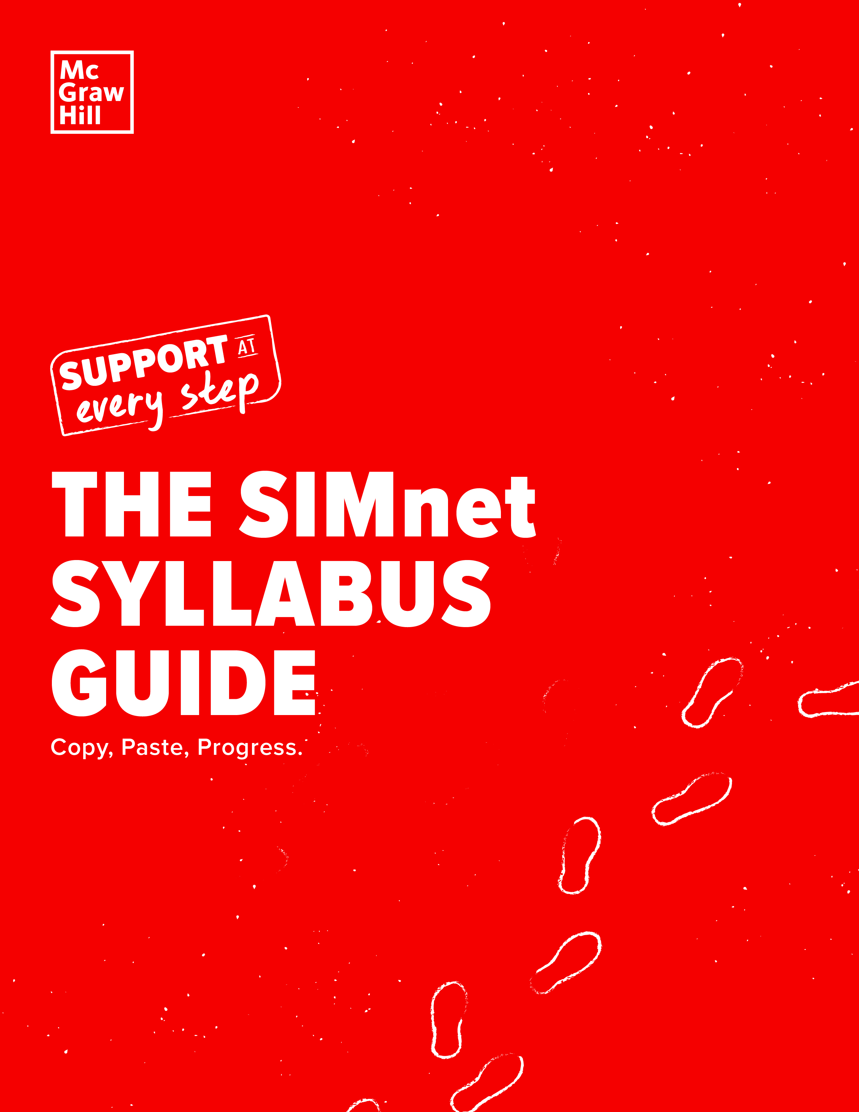

It’s crunch time, but that doesn’t mean we’re about to let you get stressed. You have support at every step of your journey, including the creation of your syllabus.

Adding SIMnet details to your syllabus is quick and easy. Get out your pen – you’ll be checking off another item on your to-do list.

In this guide, you’ll find text you can copy and paste right into your own syllabus. This content includes helpful details that cover the following:

Description of SIMnet
Student Registration and Purchase Information
How SIMnet Fits into Your Overall Course Grade
Expectations and Policies Related to Course Assignments
Technical Support Information

Copy & Paste the Following Information into Your Syllabus
A BRIEF DESCRIPTION OF SIMnet
Welcome! In this course we will use {book title, author, edition}, but not in the form of a print textbook. Instead, you will purchase access to a digital version of the book on the McGraw-Hill SIMnet® online platform. SIMnet is an online solution that teaches Microsoft Office skills and computing concepts to students of all backgrounds and majors.
Here is your REQUIRED course material:

TITLE | EDITION | AUTHOR | PUBLISHER | ISBN
 |  |  | McGraw-Hill Education
What is SIMnet?

SIMnet is an online homework and learning management platform from McGraw-Hill. Many of your course assignments will be delivered through SIMnet.
SIMnet helps you:
- Stay Organized with assignments – both in and outside of class
- Use simulations of computing applications to practice and improve your skills with instant feedback
- Review for exams with self-assessment lessons
- Track your performance with personalized reports
- Save time on studying
- Save money on textbooks
- Earn digital badges/credentials to show potential employers your technology skills
- Lifelong access to SIMnet to keep practicing your computer skills!

Copy & Paste the Options that Best Apply to Your Course
STUDENT PURCHASE & REGISTRATION INFORMATION
For this course, you will purchase access to McGraw-Hill’s SIMnet rather than buying a textbook. Here’s how:

OPTION 1 | Purchase from your school SIMnet URL:  Purchase directly from your school’s SIMnet homepage at {add SIMnet URL WEB ADDRESS}. SIMnet online is typically half the price of the printed textbook bundle.  During the registration process, you will be prompted to create a new account or login  with an existing SIMnet account, username, and password.  At that time, you will need to do one of the following:  - Enter your access code  - Purchase access online  - Begin your 14-day temporary access period
OPTION 2 | Purchase from SIMnet integrated in {add name of LMS}:  Purchase SIMnet access through your {insert LMS program} account. Login to your school’s {insert LMS program} account, click on your course, and then click on the SIMnet link, which will take you to the SIMnet registration page where you can follow the prompts.  At that time, you will need to do one of the following:  - Enter your access code  - Purchase access online  - Begin your 14-day temporary access period
OPTION 3 | Purchase from the bookstore:  Purchase a SIMnet code at the bookstore and register with the provided link or the link provided by your instructor. During the registration process, you will be prompted to create a new account or login with an existing SIMnet account, username, and password.  At that time, you will need to do one of the following:  - Enter your access code  - Purchase access online  - Begin your 14-day temporary access period
OPTION 4 | Included in Course Fees:  Your SIMnet access for this course is already available to you through your course fees.  The required course materials are accessed directly through {ENTER LMS NAME HERE}  and all materials are available the first day of class.

Copy & Paste the Following Information into Your Syllabus
HOW SIMnet FITS INTO YOUR OVERALL COURSE GRADE
SIMnet is required to complete your assignments and will be worth {insert}% of your grade.

SIMbook or Lesson/SIMpath Reading Assignments: | %
Projects: | %
Quizzes: | %
Exams: | %

Copy & Paste the Following Information into Your Syllabus
EXPECTATIONS AND POLICIES RELATED TO COURSE ASSIGNMENTS
All course assignments will be scheduled, completed, and recorded in SIMnet.
All students are required to complete every assignment by the due date listed.

Copy & Paste the Following Information into Your Syllabus
TECHNICAL AND SUPPORT INFORMATION
If you are having trouble registering for or accessing SIMnet, please contact McGraw-Hill Education’s Customer Support. Live chat, email, and phone support are available 7 days a week.

When contacting a support agent, you will always receive a case number. It will be important to save this case number if additional follow up or documentation is needed.

Website: www.mhhe.com/support | Phone: (800) 331-5094 Hours (EST)
Sunday: 12 PM - 12 AM
Monday - Thursday: 24 hours
Friday: 12 AM - 9 PM Saturday: 10 AM - 8 PM

