AEM Blog Authoring Toolkit: Content Gathering Guidelines
Before creating your blog post in AEM, start by gathering content based on the required fields outlined below. This preparation will streamline your authoring process and help ensure consistency across all blog posts.
There are four types of blog post templates available in AEM, plus a dedicated template for Author Bios.
Each template has its own layout and fields tailored to the media type, so selecting the right one from the start helps ensure proper formatting and user experience.

Get Started: Choose a Template Type to Jump to the Corresponding Content Gathering Guide
1. Article
- Best for: Written content with images
- Includes: Text body, optional inline images, main image
- Ideal for traditional blog posts, thought leadership pieces, and news-style updates
2. Podcast
- Best for: Audio-first content
- Includes: Buzzsprout audio embed only with podcast summary or transcript
- Great for promoting episodes, audio interviews, or discussions
3. Video
- Best for: Video-focused content
- Includes: Vidyard video embed only
- Use when your post centers around recorded presentations, demos, or explainers
4. PDF
- Best for: Downloadable or viewable documents
- Includes: Adobe PDF Viewer embed, brief introduction or context text
- Useful for whitepapers, research reports, or case studies
5. Author Bio
- Best for: Creating a reusable bio snipit with image and text
- Note: Do not duplicate existing authors in AEM. Only create a new Author Bio when one does not yet exist

Blog Template: Article
Please provide the following content elements for your blog post. Fields marked * are required and must be filled out before setup in AEM.
Blog Title* (max. 115 characters)
Subtitle* (max. 170 characters)
SEO Meta Description
(view SEO best practices)
Social Share Image
(view image specs)
Publish Date*
Format MM/DD/YYYY
Tags*  (learn about Tags) | Must Include Tags: Higher Ed; Blog; Article  Optional Tags:
Author(s) Bio
(see Bio best practices)
Main Image
(tip: can be same as Social Share)
Body*
Rich text formatting: headings, links, bold, etc. and can include inline images.

References
Rich text formatting: text, links, bold, etc.

Blog Template: Video
Please provide the following content elements for your blog post. Fields marked * are required and must be filled out before setup in AEM.
Blog Title* (max. 115 characters)
Subtitle* (max. 170 characters)
SEO Meta Description
(view SEO best practices)
Social Share Image
(view image specs)
Publish Date*
Format MM/DD/YYYY
Tags*  (learn about Tags) | Must Include Tags: Higher Ed; Blog; Video  Optional Tags:
Author(s) Bio
(see Bio best practices)
Body
Rich text formatting: headings, links, bold, etc. and can include inline images.

Vidyard Video ID*
(embed code only)

Blog Template: Podcast
Please provide the following content elements for your blog post. Fields marked * are required and must be filled out before setup in AEM.
Use this template if creating a new Podcast Channel that will live on this page: https://www.mheducation.com/highered/blog/resources/podcasts.html
If creating a Podcast Episode Transcript page note exceptions below:
Blog Title* (max. 115 characters)
Subtitle* (max. 170 characters)
SEO Meta Description
(view SEO best practices)
Social Share Image
(view image specs)
Publish Date*
Format MM/DD/YYYY
Tags*  (learn about Tags) | Must Include Tags: Higher Ed; Blog;  Optional Tags: Podcast (do not tag this if it’s just transcript page)
Author(s) Bio
(see Bio best practices)
Main Image
(tip: can be same as Social Share)
Body*
Rich text formatting: headings, links, bold, etc. and can include inline images.

If Transcript page, only enter the phrase
“Full Episode Transcript” here
(transcript text will be copy/pasted on the site page using a Text component)
Buzzsprout embed path*
(embed path example: <script src="https://www.buzzsprout.com/173016/episodes/16177875-marketing-algorithms.js?container_id=buzzsprout-player-16177875&player=small" type="text/javascript" charset="utf-8"></script>)

Blog Template: PDF
Please provide the following content elements for your blog post. Fields marked * are required and must be filled out before setup in AEM.

Blog Title* (max. 115 characters)
Subtitle* (max. 170 characters)
SEO Meta Description
(view SEO best practices)
Social Share Image
(view image specs)
Publish Date*
Format MM/DD/YYYY
Tags*  (learn about Tags) | Must Include Tags: Higher Ed; Blog;  Optional Tags:
Author(s) Bio
(see Bio best practices)
Main Image
(tip: can be same as Social Share)
PDF*
(view PDF best practices)

Template: Author Bio
Do not duplicate existing authors in AEM. Only create a new Author Bio when one does not yet exist.
Search in AEM to confirm if Author Bio already exists. All Higher Ed Blog Author Bio’s are listed in this folder on the DAM: /content/dam/mhe/content-fragments/blog/blog-authors/higher-ed-authors
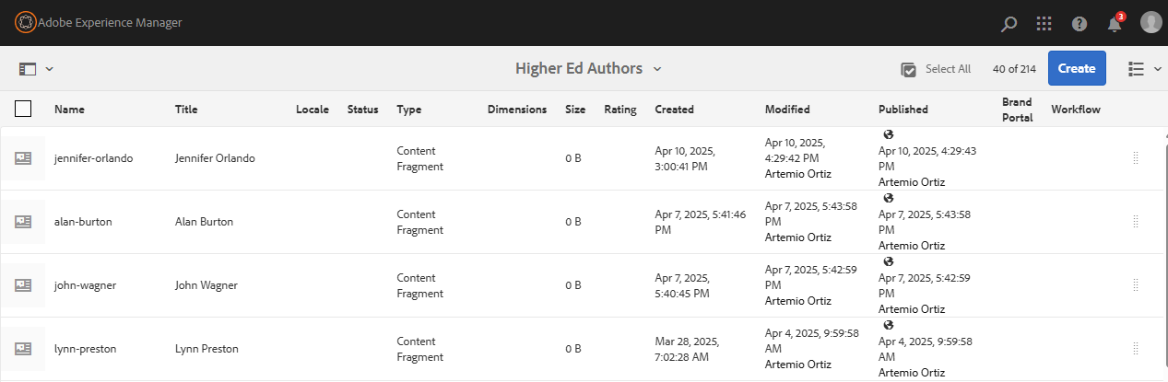
Create New Blog Author Bio:
Please provide the following content elements for the bio. Fields marked * are required and must be filled out before setup in AEM.
First name*

Last name*
Academic Suffixes
Display Name
(If different than First/Last)
Author Image
(see Author Bio image Specs)

Author Bio
Rich text formatting: text, links, bold, etc.

References
Image Best Practices:
- Avoid text in images – it can be difficult to read for users who rely on screen readers or have visual impairments. It also doesn’t scale well for responsive designs, causing issues on various devices.
- When adding text in images – If text must be included for the image design purposes like logos, infographics or charts, it’s best to describe the text separately in the images alt text to remain compliant with Accessibility Web Standards. When loading your image in AEM use the Description field in the image properties to add alt text. Alt text should be brief yet clear enough to describe the purpose of the image or its content. Think of it as a summary.
  - Avoid Using “Image of…” or “Picture of…”: Screen readers already identify that.
  - Good example: for a chart image: “Bar chart comparing sales over the past 5 years.”
- Image File Name – all lowercase letters, use hyphen to replace spaces & no special characters.
Social & Main Image Specs:
Size: 617 x 347px
File size: >200KB
Format: JPG or PNG
Location: /content/dam/mhe/blog/[current-year]/image

Social Share Image:
This is an image that displays when the blog is shared on social media and as the thumbnail when post is referenced on mheducation.com If no image is submitted, a default placeholder McGraw Hill logo will be used.
Main Image:
This will always appear full width across the post directly above the Body copy.
Author Bio Image:
Design a square image (Aspect Ratio: 1:1 Square; 400x400 px; .jpg or .png or .webp) with the subject centered and enough margin around the edges so it looks good when styled as a circle using border-radius: 50%
File name format example: [first-name]-[last-name].jpg
- all lowercase letters
- hyphen between first and last name (no spaces or underscores)
- no special characters (e.g., no accents, apostrophes, or punctuation)
Image file name format examples:
jane-smith.jpg
john-oconnor.png

References, cont.
Blog Post URL Best Practices:
- URLs should always be in lowercase
- Use hyphens to replace spaces and separate words
Good: /improving-student-engagement
Not Good: /improving_student engagement or /improvingstudentengagement
- Use only letters, numbers, and hyphens - always remove special characters and punctuation –replace characters like: !, ?, &, %, ,, ., :, ’, “ ”, #, etc.
- Apostrophes and quotation marks should be removed entirely.
- Consider removing common "stop words" like a, the, in, on, to, of unless they’re needed for clarity. Shorter URLs are better for SEO
SEO Meta Description:
This is the short description that appears in search engine results. Consider using ChatGPT* to write it using this prompt:
As an SEO Content Manager, please write an SEO Meta description for this blog post that is 160 characters or less: [insert your blog post copy here]
*AI best practice: Always use AI copy as a starting point and edit to make it your own.
PDF Best Practices:
File name format
- all lowercase letters
- hyphen between words (no spaces or underscores)
- no special characters (e.g., no accents, apostrophes, or punctuation)
Optimize File Size for Web
Compress PDFs: Reduce file size by compressing images and optimizing the PDF content without sacrificing quality, to ensure faster loading times on the web.
Embed Fonts Efficiently: If embedding fonts, only embed the characters used in the document to save space.
Remove Unnecessary Elements: Eliminate unused objects, metadata, or redundant images that can increase the file size unnecessarily.
Test PDF for Accessibility: Adobe Acrobat Accessibility Checker: Use the built-in accessibility checker in Adobe Acrobat Pro to identify issues and fix them before publishing.

References, cont.
Tagging Best Practices:
- Use Taxonomy, Not Free Entry Keywords
Taxonomy provides a structured approach to categorizing content, ensuring consistency and discoverability. Free entry keywords can lead to inconsistencies and are harder to manage.
- Business Unit
  - Tag: Always select "Higher Ed" – required tag
  - Why: Helps ensure the content is categorized under the correct business unit for reporting and search purposes.
- Asset Format Type
  - Tag: Always select "Blog" and a sub-type (e.g., Article, Case Study, Whitepaper, Video, Guide) – required tag
  - Why: This tag helps differentiate content types, making it easier for users to filter and find the relevant format of content.
- Education Topics
  - Tag: Match to an existing blog topic page, example Analytics Insider
  - Why: Helps align content with specific subject areas or courses, ensuring relevant traffic is directed to the right content.
- Programs & Solutions
  - Tag: Use branded terms like "Connect" or "Sharpen"
  - Why: Identifies content related to specific programs or solutions offered by MHE, aiding in campaign tracking and program-focused searches.
- Personas
  - Tag: Target audience (e.g., "Higher Ed Student")
  - Why: Tags the content based on the intended reader, helping personalize and tailor content for specific audiences.
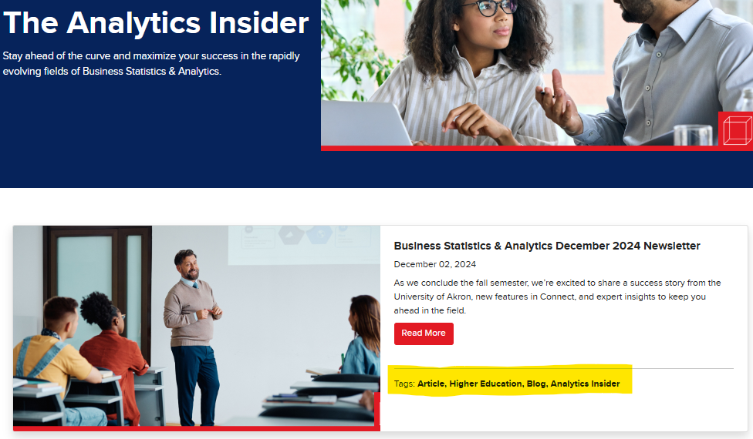
Tagging Process
Tags are added individually using the tag selector tool in AEM. For reference on available tags, please refer to the Tag Spreadsheet.
If a new tag is required, please submit a request to COE in Asana for review and approval.

